**Instance at 2 different AZ & Auto Scaling Group instance**

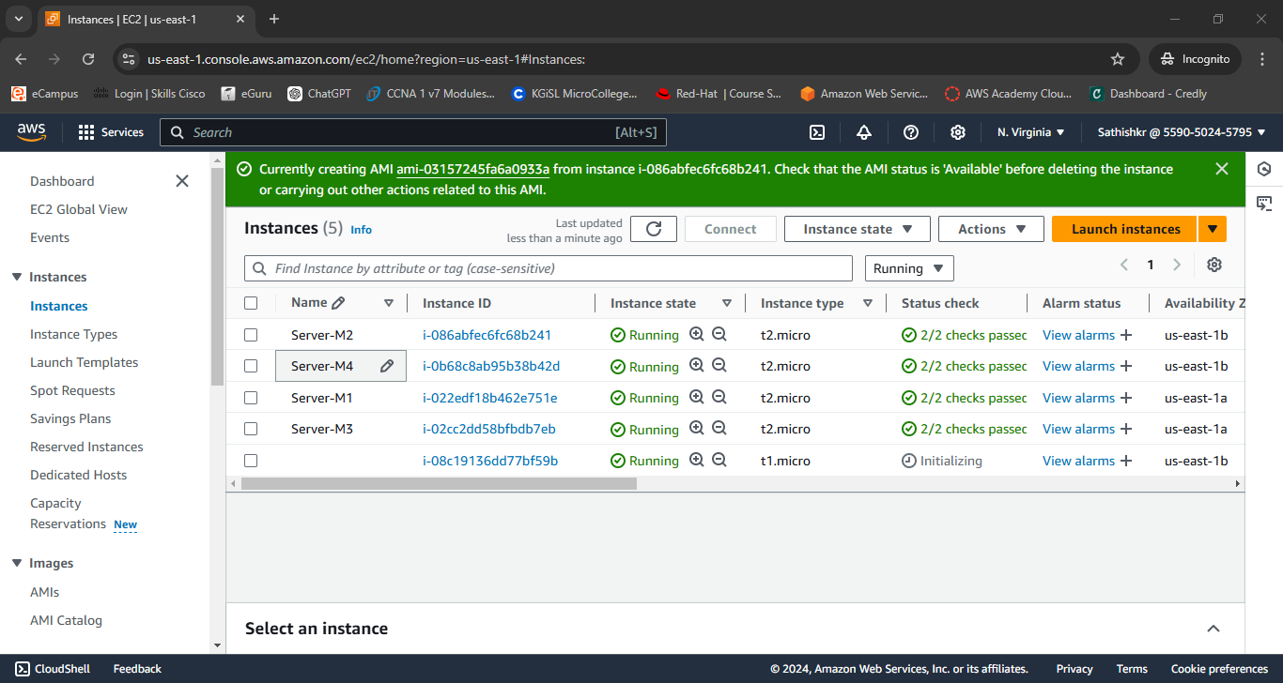

**AMI of Server-M2**

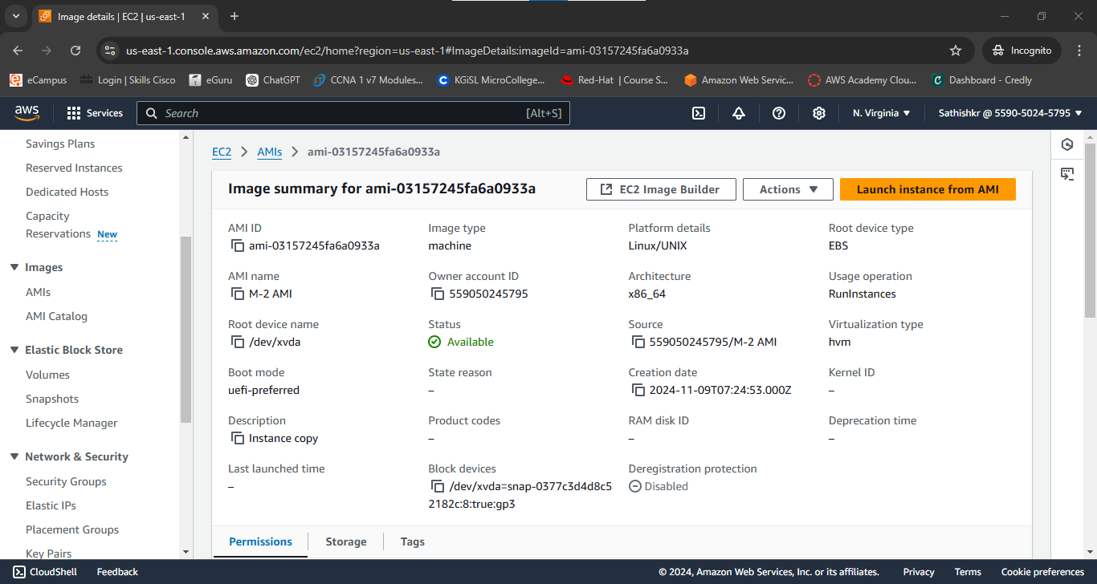

**Template launched from AMI of Server-M2**

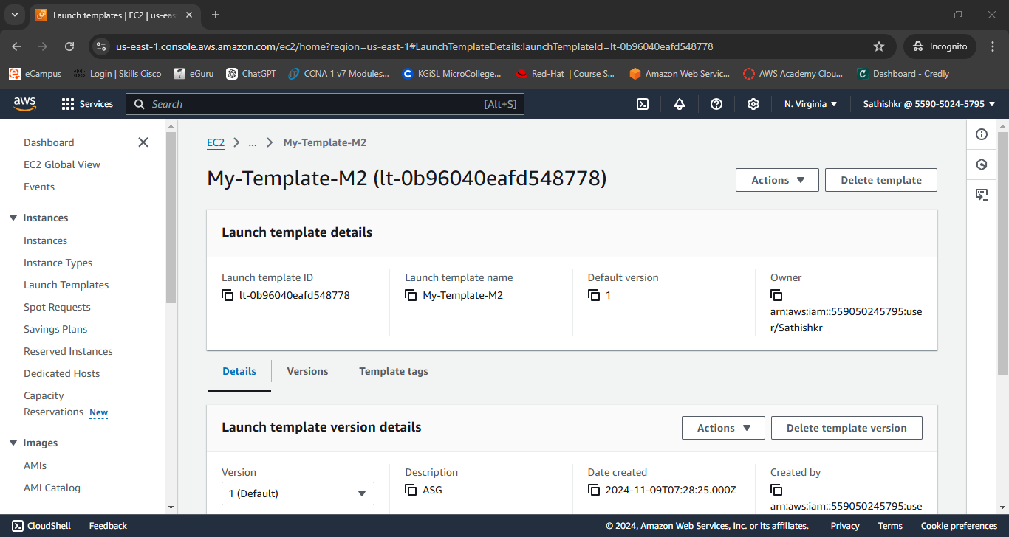

**Target Group created with Server-M1&2**

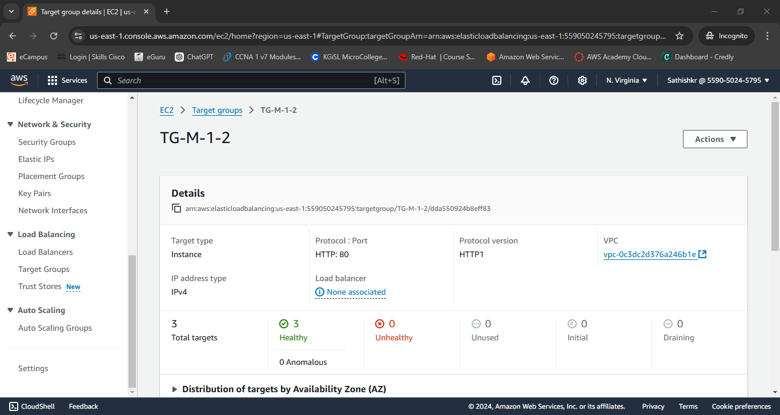

**Load Balancer for Server M-1&2**

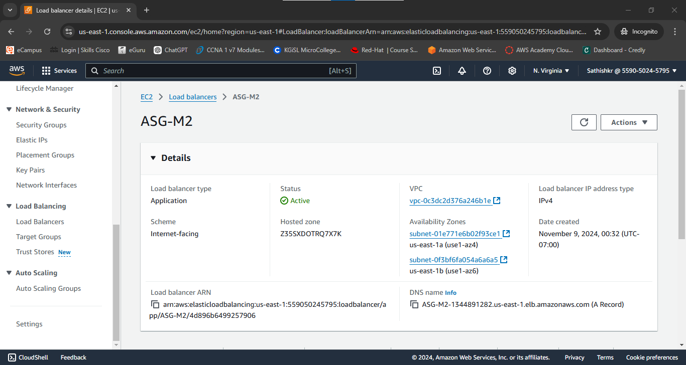

**Auto scaling group**

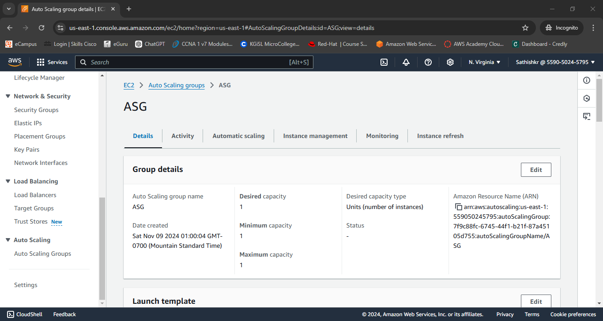

**EBS New Volume attached with Server-M4**

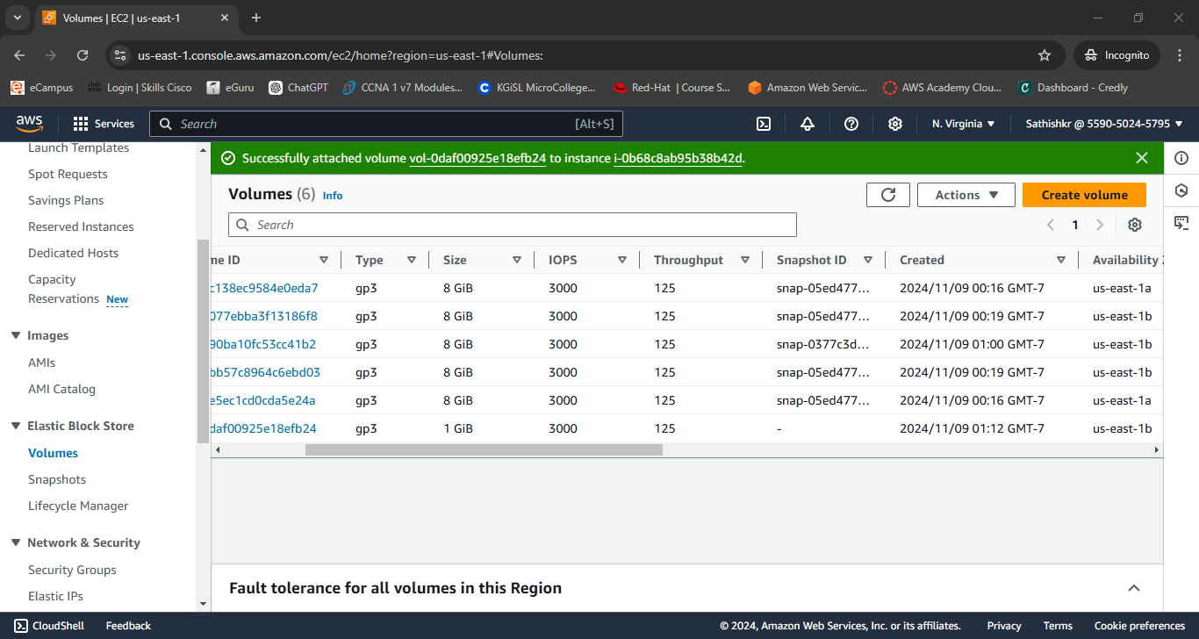

**Attached volume in server-M4 and create files in mounted disk /dev/xvdb with directory /crop**

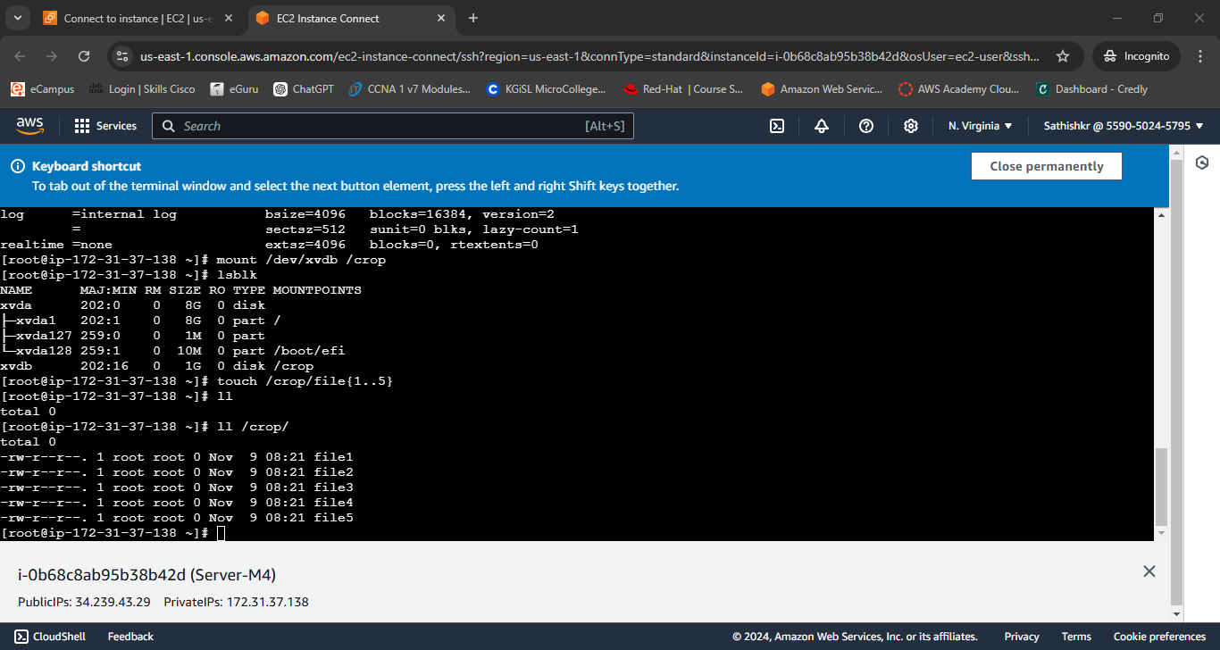

**Detached from Server-M4**

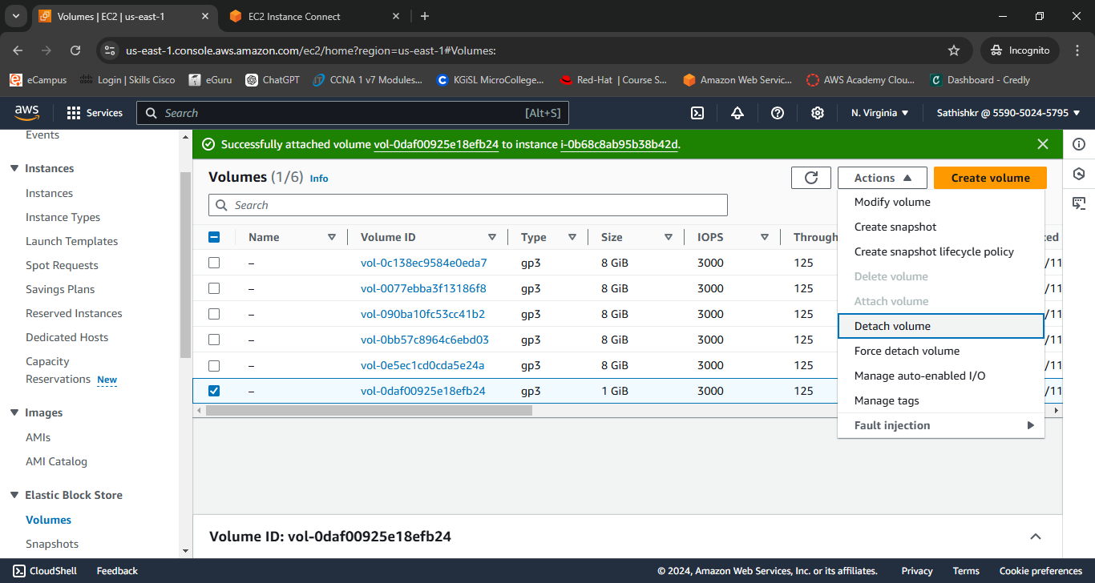

**Snapshot created for EBS to use at another AZ**

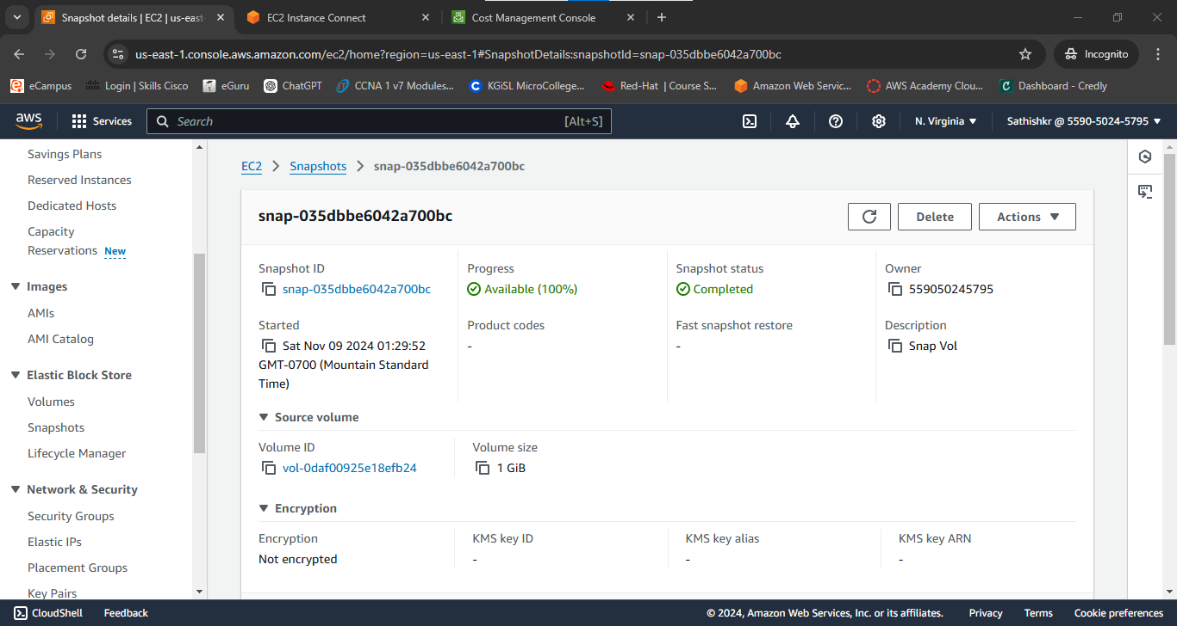

**Server-M3 from another region viewed it**

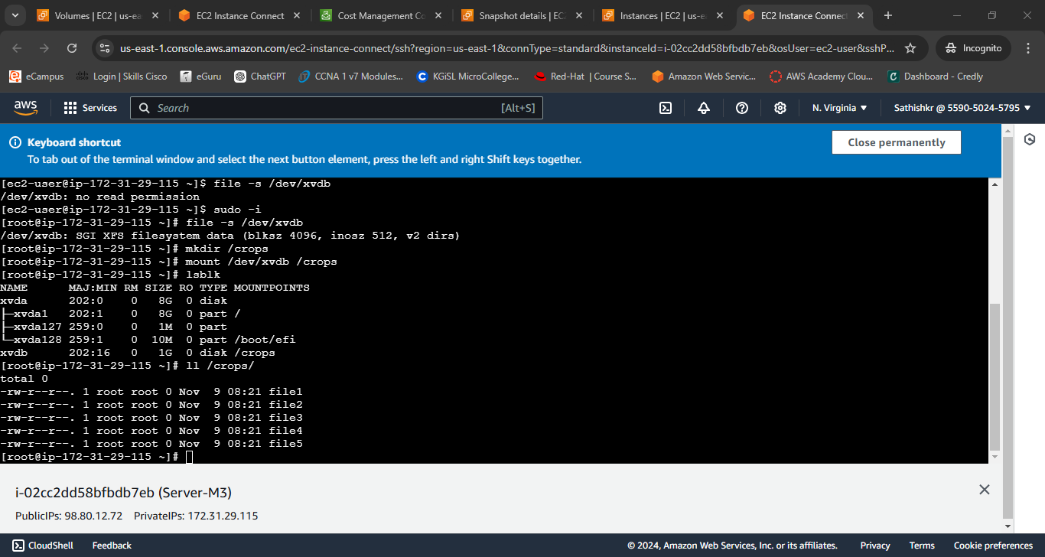

**EFS file system created**

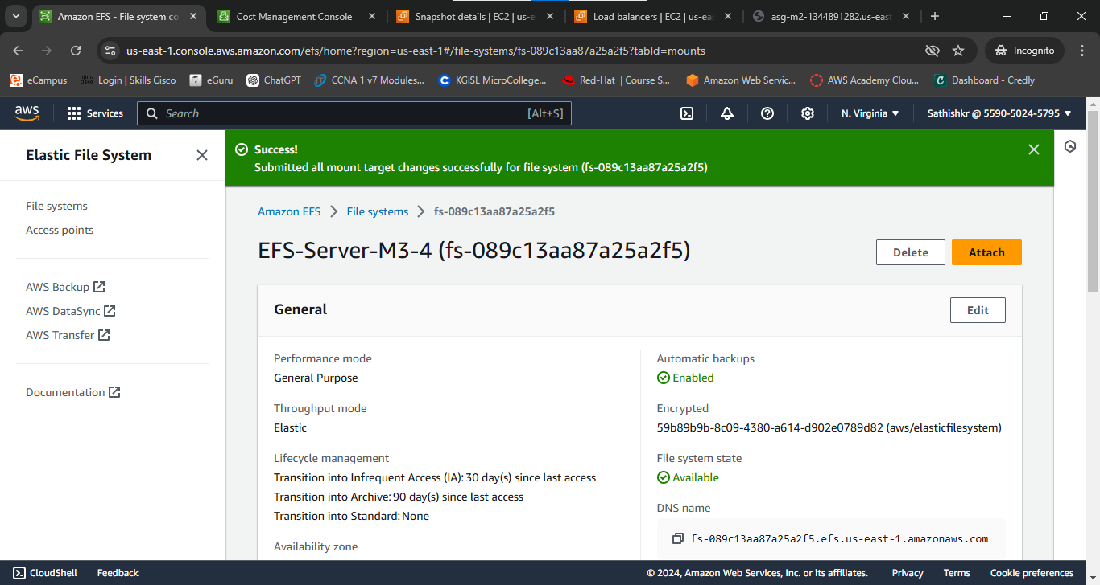

**Touch files inSerer-M4 mount using ip**

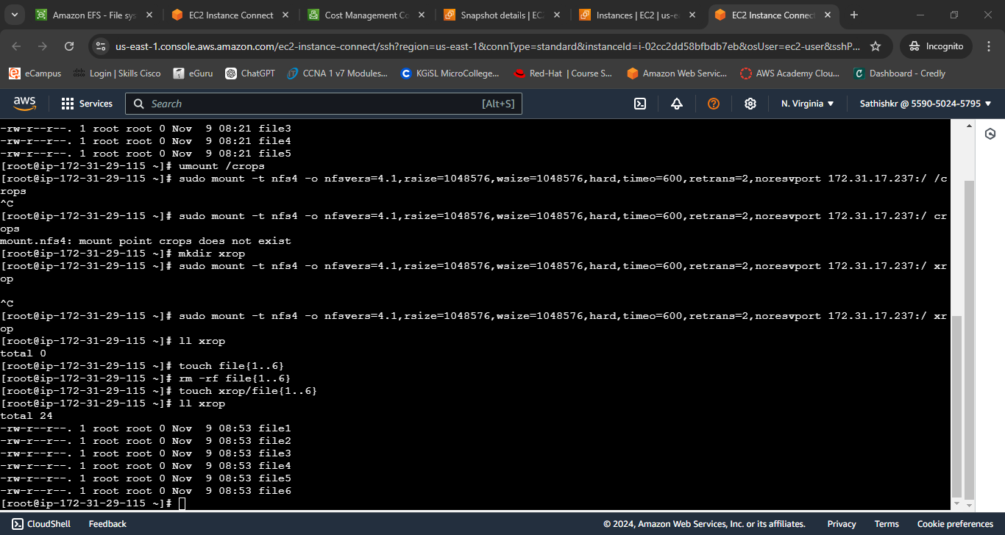

**Viewed file using another instance Server-M3**

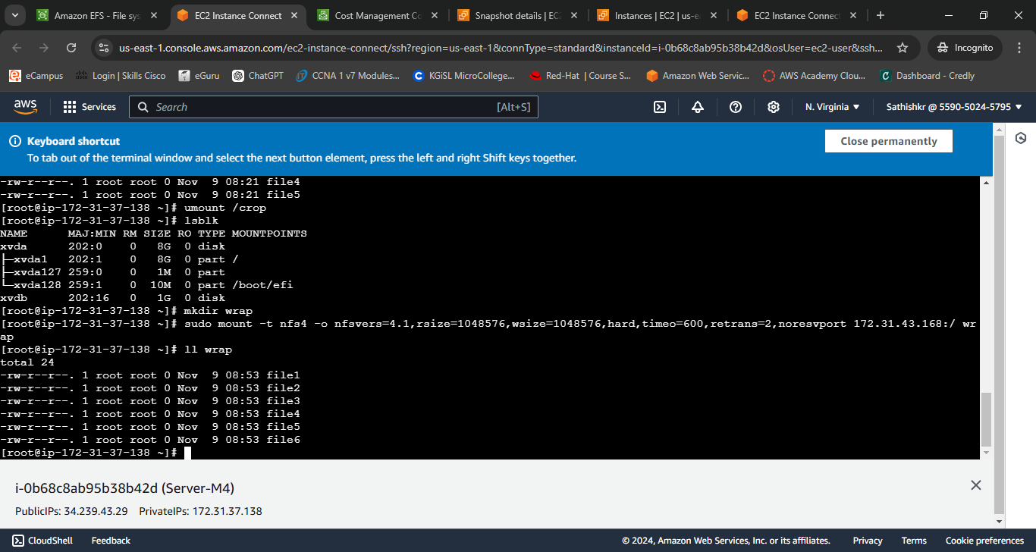

**Load Balancer output screen-1**

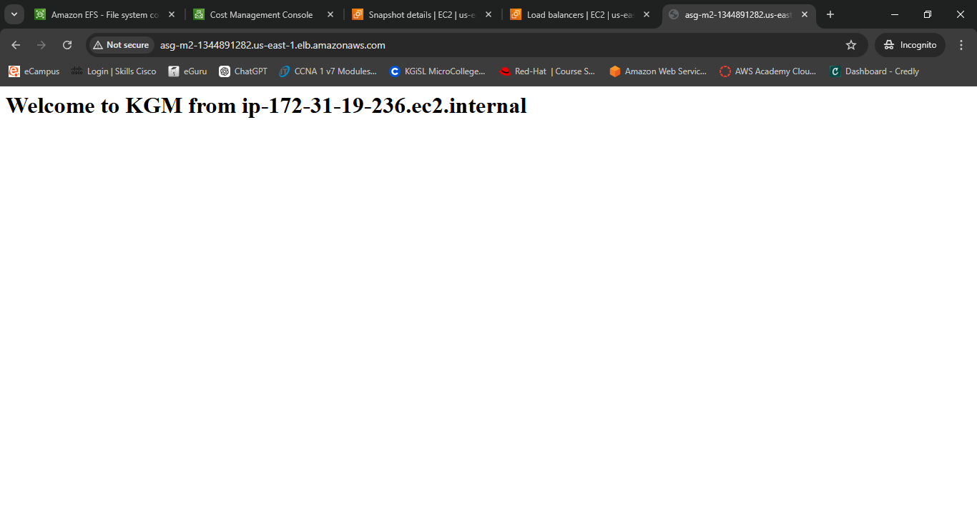

**Load Balancer output screen-2**

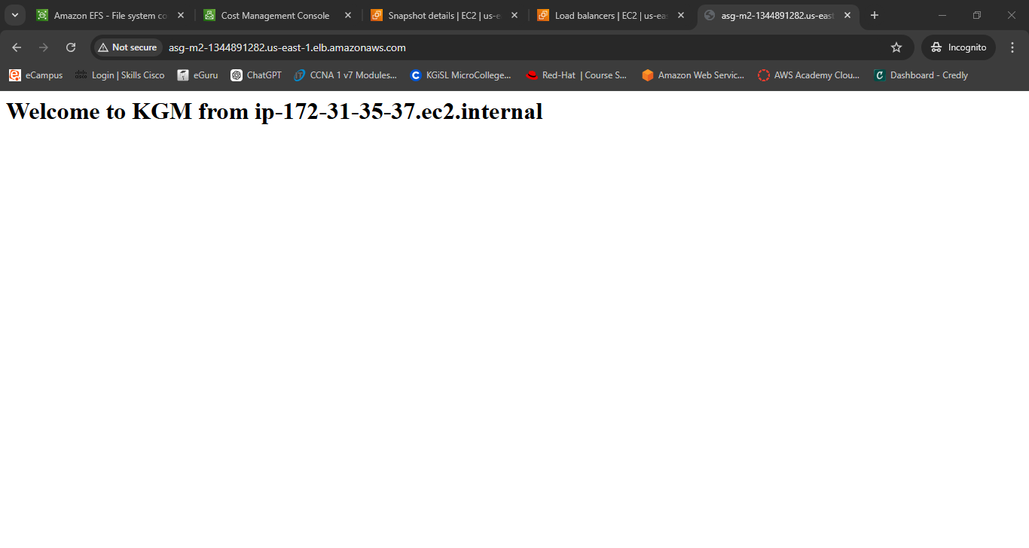

**Output screen of Auto scaling server done with the help of Server-M2**

